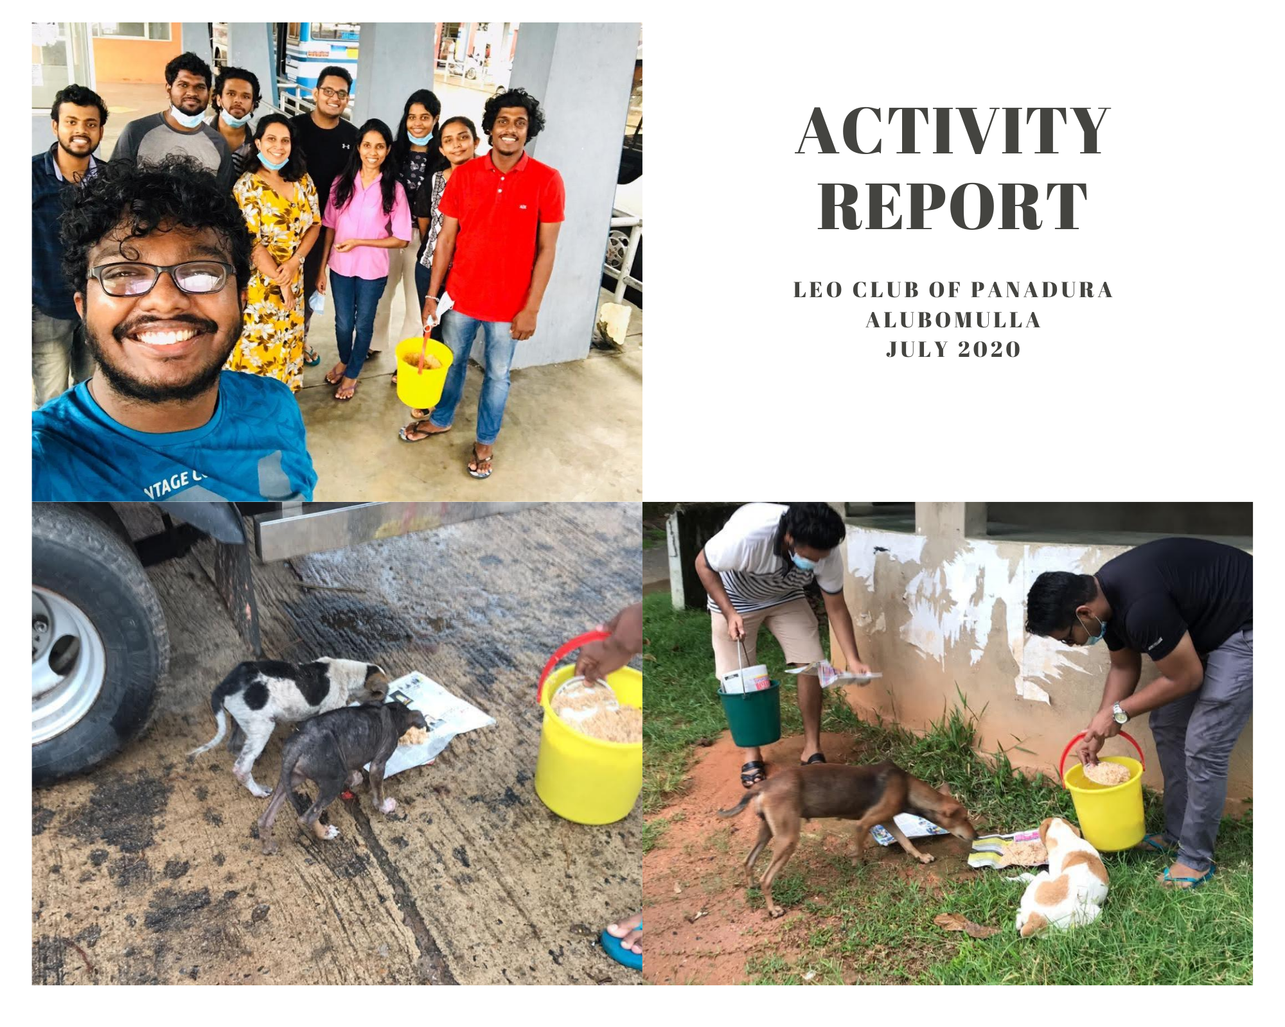

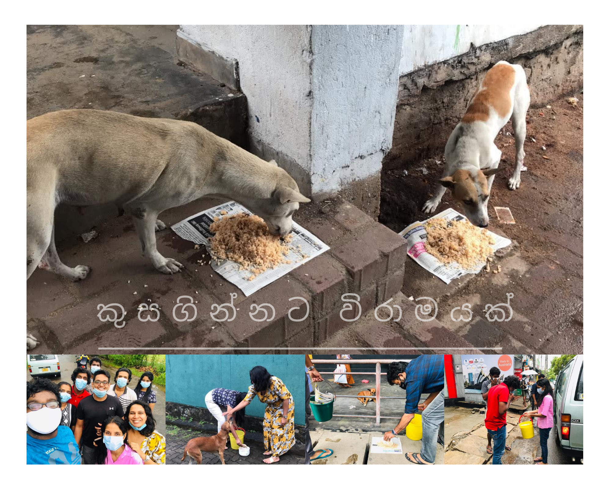

Secretary name: Minidu Wickramaarchchi

Submission date:

**SUBMISSION DATE:**

**LEO SECRETARY:** Minidu Wickramaarachchi

LEO CLUB OF PANADURA ALUBOMULLA  
LIONS CLUBS INTERNATIONAL DISTRICT 306 A2 SRI LANKA

**President**

Leo Naveen Madhusanka

No 119/C,

Weerasinghe Road,

Niwandama,

Ja-Ela.

[infornaveen@gmail.com](mailto:infornaveen@gmail.com)

071-6306781

**Secretary**

Leo Minidu Wickramaarachchi

No 129/A,

Suwasewa Mawatha,

Maha-heenatiyangala,

Kalutara South.

[Miniduwickramaarchchi97@gmail.com](mailto:Miniduwickramaarchchi97@gmail.com)

071-6950344

**Treasurer**

Leo Nadini Amarakoon

No 38/10,

Wijayaraja Mawatha,

Nikape Road,

Dehiwala.

[nadinidinethya@gmail.com](mailto:nadinidinethya@gmail.com)

071-8724946

**Vice President**

Leo Ravindu Poornajith

No 194/1,

Kanda Temple Road,

Mahawaskaduwa,

Waskaduwa.

[Rpoornajith1997@gmail.com](mailto:Rpoornajith1997@gmail.com)

071-3620336

**Directors**

Leo Tharuka Indrajith

Leo Isuru Wickramarathne

Leo Kalana Tebel

Leo Pasindu Chanushka

Leo Hasindu Goonathilaka

**Leo Advisor**

Lion Nihal de Silva

No.7, Nimalka gardens, Panadura

[nihaldesilva31@gmail.com](mailto:nihaldesilva31@gmail.com)

071-6386701

02/09/2020

Leo Praminda Vindika,

District President 2020/21,

Leo District 306A2- Sri Lanka

**MONTHLY SECRETARY REPORT – JULY 2020**

Attached herewith is the Monthly secretary report of the Leo Club of Panadura Alubomulla, for the month of August 2020.

I hereby confirm that all necessary documents required for the district contest is attached here and all information provided is true and accurate.

Thank you.

Yours Sincerely,

..................................

Leo Minidu Wickramaarachchi,   
Secretary,   
Leo Club of Panadura Alubomulla.



Table of Contents

1. Declaration 4

2. Club Administration Summary August 2020 5

3. Summary of Leo Club Meetings 6

4. Meeting Attendance of Leo Club officers July 2020 7

5. Membership Report July 2020 8

6. Summary of Participation of Club Members in Events 11

7. Points Claiming Summary 12

8. Sample project Report 13

# Declaration



LEO CLUB OF PANADURA ALUBOMULLA  
LIONS CLUBS INTERNATIONAL DISTRICT 306 A2 SRI LANKA

We certify that the information present in this activity report is true and correct.

…………………………….

Leo Club President

…………………………….

Leo Club Secretary

…………………………….

Leo Club Treasurer

…………………………….

Leo Advisor

…………………………….

Staff Advisor

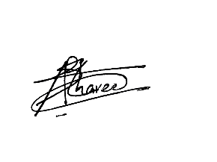







# Club Administration Summary August 2020



LEO CLUB OF PANADURA ALUBOMULLA  
LIONS CLUBS INTERNATIONAL DISTRICT 306 A2 SRI LANKA

|  |  |
| --- | --- |
| **MEMBERSHIP** | |
| No. of members as at previous month | 17 |
| No. of members inducted | - |
| No. of members dropped | - |
| No. of members as at present month | 17 |
| No. of board members | 05 |

|  |  |
| --- | --- |
| **MEETINGS** | |
| General Meeting Date | 15-08-2020 |
| District/Multiple officer visited | District President Leo Praminda Vindika |
| Leo advisor’s presence in general meeting | yes |
| Board Meeting Date | 13-08-2020 |
| No. of members presented in Board Meeting | 08 |

|  |  |
| --- | --- |
| **PROJECTS** | |
| Number of Projects conducted for this month | 0 |

|  |  |
| --- | --- |
| **FINANCES** | |
| Total surplus or deficit for the period | 7000 |
| Total receivables | - |
| Total payables | 4500 (multiple and district dues for 2020-2021) |

# Summary of Leo Club Meetings



LEO CLUB OF PANADURA ALUBOMULLA  
LIONS CLUBS INTERNATIONAL DISTRICT 306 A2 SRI LANKA

**GENERAL MEETING**

|  |  |  |  |  |
| --- | --- | --- | --- | --- |
| Date | 15-08-2020 | Time | 3.00p.m | |
| Venue | Leo Santhrushika’s place | | | |
|  | | | | |
| **Participation** | | | | |
| **Chief Guest** |  | **Guest of Honor** | | |
| Name | Leo Praminda Vindika | Name | Leo Mudith Jayasekara | |
| Designation | District President | Designation | IPDP | |
|  | | | | |
| Leos | 07 |  | | Present/ Absent |
| Leo Prospects | 00 | Club President | | ✓ |
| Lions/Lionesses | 00 | Club Vice President | | ✓ |
| Council Mem | 02 | Club Secretary | | ✓ |
| Visiting Leos | 00 | Club Treasurer | | ✓ |
| Leo Parents | 00 | Leo Advisor | | ✓ |
| Guests | 00 | Staff Advisor | | 🗶 |
| Percentage of attendance % | 52% | | | |

**BOARD MEETING**

|  |  |  |  |
| --- | --- | --- | --- |
| Date | 13-08-2020 | Time | 9.00p.m |
| Venue | Online via Zoom | | |
| No. of board members present | | 8 | |
| Percentage of attendance % | | 88% | |
| Leo Advisor/Acting Leo Advisor | | Absent | |

**PHOTOS OF GENERAL MEETING AND BOARD MEETING**

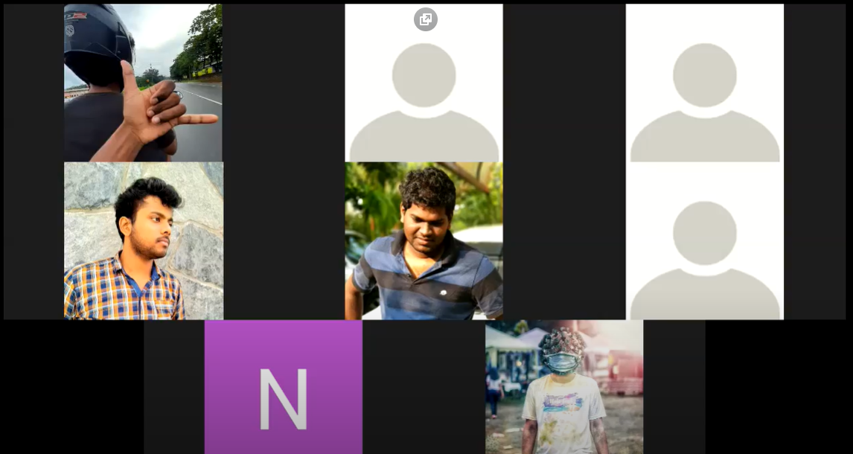

Figure ‑ : Board Meeting

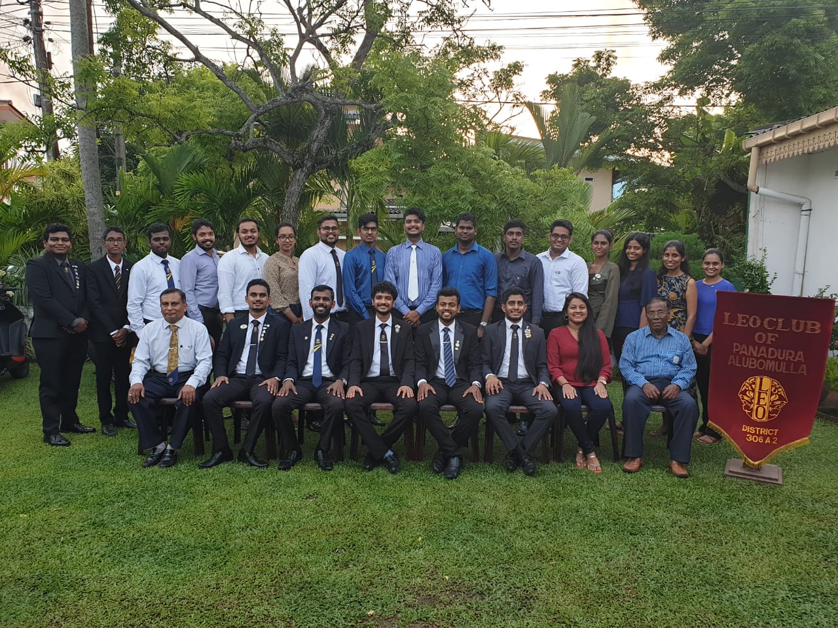

Figure ‑: General Meeting

**ATTENDANCE LISTS**

Attendance list is attached bellow.

# Meeting Attendance of Leo Club officers August 2020



LEO CLUB OF PANADURA ALUBOMULLA  
LIONS CLUBS INTERNATIONAL DISTRICT 306 A2 SRI LANKA

|  |  |  |  |
| --- | --- | --- | --- |
| **Designation** | **Name** | **Participation** | |
| **General Meeting** | **Board Meeting** |
| President | Naveen Madhusanka | ✓ | ✓ |
| Vice President | Ravindu Poornajith | ✓ | ✓ |
| Secretary | Minidu Wickramaarachchi | ✓ | ✓ |
| Treasurer | Nadini Amarakoon | ✓ | ✓ |
| Leo Advisor | Nihal de Silva | ✓ | 🗶 |
| Director | Tharuka Indrajith | 🗶 | 🗶 |
| Director | Isuru Wickramarathne | ✓ | ✓ |
| Director | Kalana Tebel | ✓ | ✓ |
| Director | Pasindu Chanushka | 🗶 | ✓ |
| Director | Hasindu Goonathilaka | ✓ | ✓ |

# Membership Report August 2020



LEO CLUB OF PANADURA ALUBOMULLA  
LIONS CLUBS INTERNATIONAL DISTRICT 306 A2 SRI LANKA

**LEO CLUB OFFICERS**

|  |  |  |  |
| --- | --- | --- | --- |
| **Designation** | **Name** | **Contact Number** | **E-Mail** |
| President | Naveen Madhusanka | 0716306781 | [infornaveen@gmail.com](mailto:infornaveen@gmail.com) |
| Vice President | Ravindu Poornajith | 0713620336 | [Rpoornajith1997@gmail.com](mailto:Rpoornajith1997@gmail.com) |
| Secretary | Minidu Wickramaarachchi | 0716950344 | [Miniduwickramaarchchi97@gmail.com](mailto:Miniduwickramaarchchi97@gmail.com) |
| Treasurer | Nadini Amarakoon | 0718724946 | [nadinidinethya@gmail.com](mailto:nadinidinethya@gmail.com) |
| Asst. Secretaries | Santhrushika de Silva | 0713544281 | [sanudesilva31@gmail.com](mailto:sanudesilva31@gmail.com) |
| Asst. Treasurers | **-** | - | - |
| Leo Advisor | Nihal de Silva | 0716386701 | [nihaldesilva31@gmail.com](mailto:nihaldesilva31@gmail.com) |
| Director | Tharuka Indrajith | 0715921705 | [Tharuka.indrajith1997@gmail.com](mailto:Tharuka.indrajith1997@gmail.com) |
| Director | Isuru Wickramarathne | 0716017249 | [isuruwickramarathne@gmail.com](mailto:isuruwickramarathne@gmail.com) |
| Director | Kalana Tebel | 0771713114 | [Kalanamtebel97@gmail.com](mailto:Kalanamtebel97@gmail.com) |
| Director | Pasindu Chanushka | 0714706525 | [pasinduchanusha@gmail.com](mailto:pasinduchanusha@gmail.com) |
| Director | Hasindu Goonathilaka | 0716538324 | [Lexaaxa1@gmail.com](mailto:Lexaaxa1@gmail.com) |

**FULL MEMBERSHIP REPORT**

|  |  |  |  |  |  |  |
| --- | --- | --- | --- | --- | --- | --- |
| **No** | **Name** | **NIC** | **Address** | **Contact Number** | **E-Mail** | **MyLCI No.** |
| 1 | Santhrushika de Silva | 917442053v | No.7, Nimalka Gardens, Panadura | 713544281 | [sanudesilva31@gmail.com](mailto:sanudesilva31@gmail.com) | 3817945 |
| 2 | Nadee Dayaratne |  |  | 713544281 | [nadeebhagya@gmail.com](mailto:nadeebhagya@gmail.com) | 4008870 |
| 3 | Eraj Gunawardena | 950791187v | 22/1, wickrama mawatha, panadura | 713248566 | [ravindueraj@gmail.com](mailto:ravindueraj@gmail.com) | 4054159 |
| 4 | Thusara Narampanawa | 973333879v | 64,Nimthera Asapuwa,Kaluthra South | 778445629 | [thusaradons@gmail.com](mailto:thusaradons@gmail.com) | 5058561 |
| 5 | Tharuka Karunamuni | 971411066v | 194/1 Kanda temple Rd,Mahawaskaduwa,Waskaduwa | 715921705 | [tharuka.indrajith1997@gmail.com](mailto:tharuka.indrajith1997@gmail.com) | 4847430 |
| 6 | Ravindu Karunamuni | 971411856v | 194/1 Kanda temple Rd,Mahawaskaduwa,Waskaduwa | 713620336 | [rpoornajith1997@gmail.com](mailto:rpoornajith1997@gmail.com) | 4847431 |
| 7 | Kalana Tebel | 973491458v | 28/1A,Samantha Mw,Arthur V Dias Mw,Panadura | 771713114 | [kalanamtebel97@gmail.com](mailto:kalanamtebel97@gmail.com) | 4964303 |
| 8 | Naveen Madushanka | 95100720v | 119/C Weerasinghe Mw,Niwandama,Ja-Ela | 716306781 | [infornaveen@gmail.com](mailto:infornaveen@gmail.com) | 5058538 |
| 9 | Rushan Nanayakkara | 952153560v | 3B, Samudra Mawatha, Panadura | 776068772 | [rushannanayakkara@gmail.com](mailto:rushannanayakkara@gmail.com) | 5058555 |
| 10 | Natasha de Silva | 925800198v | No396/1,"Srikantha",Galle Road,Thalpitiya South,Wadduwa | 767162500 | sachini_natasha@hotmail.com | 4053965 |
| 11 | Kosala Gunathilake | 957083498v | 42/06, Weragama Rd, Wadduwa | 773754451 |  | 5058568 |
| 12 | Hawanjana Lanka Fernando | 977581060v | No.14B, Cinnamon Rd, Kaludewala, Panadura | 775546136 | [lankafernando45@gmail.com](mailto:lankafernando45@gmail.com) | 5058179 |
| 13 | Isuru Mendis Wickramarathna | 980261972v | 24th Mile Post, Maha Waskaduwa, Waskaduwa | 716017249 | [isuruwickramarathna@gmail.com](mailto:isuruwickramarathna@gmail.com) | 5058170 |
| 14 | Hasindu Nethmal Goonathilake | 973070797v | No.35, Temple Lane, Maha vihara Rd,Wadduwa | 716538324 | [lexaaxa1@gmail.com](mailto:lexaaxa1@gmail.com) | 5058168 |
| 15 | Pasindu Chanusha Sooriyabandara | 971243040v | No.259/1, Thushari, Pushparama Rd, Pothupitiya, wadduwa | 714706525 | [pasinduchanusha@gmail.com](mailto:pasinduchanusha@gmail.com) | 5058176 |
| 16 | Minidu Wickramaarachchi | 972990655v | 129A,Suwasewana Mw, Mahaheenatiyangala, Kalutara South | 716950344 | [miniduwickramaarchchi97@gmail.com](mailto:miniduwickramaarchchi97@gmail.com) | 5264145 |
| 17 | Nadini Amarakoon | 996970272v | 38/10, Wijayaraja Mw, Nikape Rd, Dehiwala | 718724946 | [nadinidinethya@gmail.com](mailto:nadinidinethya@gmail.com) | 5264127 |

**NAME AND CONTACT DETAILS OF NEW LEOS INCLUDED**

|  |  |  |  |  |  |  |  |  |
| --- | --- | --- | --- | --- | --- | --- | --- | --- |
| **No** | **Name** | **NIC** | **Address** | **Contact Number** | **E-Mail** | **DOB** | **MyLCI No.** | **Prospect Period** |
| 1 |  |  |  |  |  |  |  |  |
| 2 |  |  |  |  |  |  |  |  |
| 3 |  |  |  |  |  |  |  |  |
| 4 |  |  |  |  |  |  |  |  |
| 5 |  |  |  |  |  |  |  |  |

**NAME AND CONTACT DETAILS OF LEOS EXCLUDED**

|  |  |  |  |  |
| --- | --- | --- | --- | --- |
| **No** | **Name** | **NIC** | **E-Mail** | **MyLCI No.** |
| 1 | Gayanath Hidallarachchi |  | gayanath2011@hotmail.com | 4032121 |
| 2 | Pasan Kalanjith |  | [kalanajith.pasan@gmail.com](mailto:kalanajith.pasan@gmail.com) | 4054083 |
| 3 | Chanaka Wijebandara |  |  | 4847434 |
| 4 | Kushan Perera |  |  | 5058570 |

# Summary of Participation of Club Members in Events



LEO CLUB OF PANADURA ALUBOMULLA  
LIONS CLUBS INTERNATIONAL DISTRICT 306 A2 SRI LANKA

|  |  |  |  |
| --- | --- | --- | --- |
| **Participations at District Events** | | | |
| **Event** | **Date** | **No. of Club members** | **Names of Club members** |
| Club Officers Workshop | 09-08-2020 | 03 | Naveen Madhusanka  Ravindu Poornajith  Minidu Wickramaarachchi |
|  |  |  |  |

|  |  |  |  |
| --- | --- | --- | --- |
| **Participations at Multiple District Events** | | | |
| **Event** | **Date** | **No. of Club members** | **Names of Club members** |
|  |  |  |  |

|  |  |  |  |
| --- | --- | --- | --- |
| **Participations at Lions Club/District Events** | | | |
| **Event** | **Date** | **No. of Club members** | **Names of Club members** |
|  |  |  |  |

|  |  |  |  |
| --- | --- | --- | --- |
| **Visits to other Club Events** | | | |
| **Event** | **Date** | **No. of Club members** | **Names of Club members** |
|  |  |  |  |

|  |  |  |  |
| --- | --- | --- | --- |
| **Participations at Outside Organizational Events** | | | |
| **Event** | **Date** | **No. of Club members** | **Names of Club members** |
|  |  |  |  |

# Points Claiming Summary



LEO CLUB OF PANADURA ALUBOMULLA  
LIONS CLUBS INTERNATIONAL DISTRICT 306 A2 SRI LANKA

|  |  |
| --- | --- |
| **Project Name** | **District Contest Code** |
| General Meeting | **A3(b)** |
| Board Meeting | **A4(b)**  **A9(b)** |
| Club Officers Workshop | **B2(b)*3** |
| Kusaginnata Wiramayak | **C3(b)**  **C3(c)**  **C3(g)i**  **C1(b)**  **C2(r)**  **C2(t)**  **C2(e)** |
| Public Relations | **E(f)**  **E(g)**  **E(h)**  **E(i)** |

# Sample project Report



LEO CLUB OF PANADURA ALUBOMULLA  
LIONS CLUBS INTERNATIONAL DISTRICT 306 A2 SRI LANKA

PROJECT NEED ASSESSMENT

**Nightfall Rhythmic**

|  |  |
| --- | --- |
| **Benefiting**  **community** | We aimed towards the union of other club members. |
| **Identified Community**  **Need** | The identified problem was that there’s no specific event to gather with club members. |
| **Service Opportunity** | **Identified opportunities for projects.**   * Organizing a special event for gathering. * After installation party as club members will remain for dinner.   **Resources that were available locally at the time.**   * Installation ceremony was there to be held. * As other club members are participating, it might be the best chance to do something like that.   **The selection of the project.**  This was organized on 15th of August 2020, it was our installation day of Panadura Alubomulla Leo club. So we decided to select that day because many of the other Leos also going to participate for the installation ceremony. |
| **Mode of Data Collection** | With related to the requests of club members. |

|  |  |
| --- | --- |
| PROJECT PROPOSAL | |
| **Focused Project Category** | (s) For all kind of service projects |
| **Proposed Project Plan** | **Project Idea Description**  We aiming to serve food for the stray dogs as they can’t find food with the pandemic situation of the country.  **Idea generation from?**  We observed the situation going on the country at the moment.  **Challenges to the implementation**   * Finding a sponsorship for the project was bit tough with the situation. * Limited number of shops open. * Cannot gather big amount of people in a one place. * Getting permission for the project.   **Leo organizers involvement**  As we planned to go with the self-prepared method, majority of members promised to supply with materials for the project. With relative to that we planned to purchase other materials. |
| **Estimated net expenses** | Rs.2000/- |
| APPROVAL | |
| **Remarks from Board of Directors** | Decided to stick with the self-preparation method. |
| **Approval granted?** | Yes |
| **Club president signature** |  |

SERVICE CONTEST FORM

|  |  |  |  |  |
| --- | --- | --- | --- | --- |
| **Project Title** | Nightfall Rhythmic | |  |  |
| **Project Category** |  | |  |  |
| **Date** | 15-08-20 | |  |  |
| **Time** | After the installation ceremony | |  |  |
| **Venue** | Leo Lion Nimeshika De Silva’s place | |  |  |
| **Chief Guest** | Name | Leo Praminda Vindika |  |  |
| Designation | District President |  |  |
| **Project Chairman** | Leo Kalana Tebel | |  |  |
| **Project Secretary** | - | |  |  |
| **Project Treasurer** | - | |  |  |
| **No. of Beneficiaries** | About 25 | |  |  |
| **Project Value** |  | |  |  |
| **Mode of funds raised** | Club member donations. | |  |  |
| **Participants** | Leos | 09 |  |  |
| Prospects | - |  |  |
| Visiting Leos | - |  |  |
| Council Members | - |  |  |
| Lions | 02 |  |  |
| Outsiders | - |  |  |
| **Service Hours** | 3 hours | |  |  |
| **Jointly organized with** | No | |  |  |
| **Is this an annual/continuous project done in the previous year?** | No | |  |  |
| **If yes, explain the innovativeness in 2020/2021** |  | |  |  |
| **Brief Description about the project**  **(Project objective)** | It is a project which organized to improve the connection and unity of club members and other club members. | |  |  |
| **Project Description** | After getting the approval of the members and the club president we discussed the way to gather goods for the project. As it went in a good manner the members who have promised to provide with supplies, have bought their items before the beginning of the project. Then we made the food for dogs and went on a journey around Panadura area looking for dogs and cats. When come to challenges of the project there were many, with the situation of the country we didn’t able to gather at some places, had to wear masks all the time even the hardest of the all was the rain. All the members gave their fullest support without considering the rain. In the rain our Leo adviser Lion Nihal De Silva uncle provided us with transportation facility around Panadura area, with the help of him we manage to overcome many obstacles without any second thoughts.  When come to feedbacks, so many people appreciated the work we are doing and it was a help too when come to take permission. At last we manage to cover most of the Panadura area due to the rain there were minimum number of dogs and cats, but comparing to the previous years it was a improvement because previously we stick to a one single area. | |  |  |
|  |  |  |  |  |

PHOTOGRAPHS

|  |  |
| --- | --- |
| Figure : Project Flair | Figure : Participated Members |
| Figure : Feeding dongs near a car park | Figure : Feeding dogs near Panadura Bus stand |
| Figure : Feeding Dogs near a junction | Figure : Another Feeding Picture |

PROJECT TREASURERE REPORT

|  |  |
| --- | --- |
| **Description** | **Amount** |
| **RECEIPTS** | |
| Donations from club members | Rs. 450/- |
| Donation from Leo Nimeshika and Santhrushika De Silva | Rs. 820/- |
| Total Receipts | Rs. 1270/- |
| **EXPENCES** |  |
| Rice | Rs. 450/- |
| Chicken Curry | Rs. 820/- |
|  |  |
| Total expenses | Rs.1270/- |

Project participation list

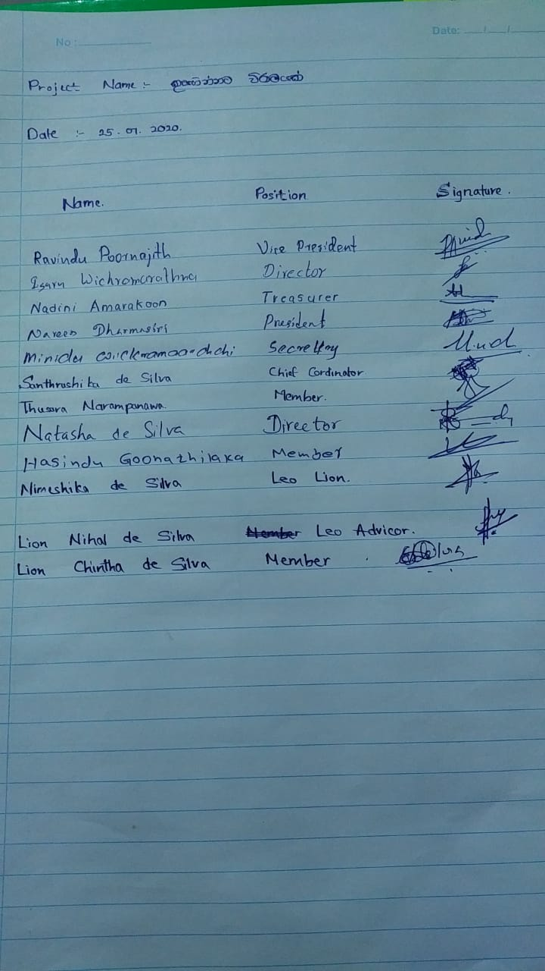

Project video Link

<https://drive.google.com/file/d/1nus5mRrWHBK7IN5LwL65G2eHZTeWQwcQ/view?usp=sharing>